**KARPAGA VINAYAGA**

**COLLEGE OF ENGINEERING AND TECHNOLOGY**

**GSTRoad-ChinnaKolambakkam-MadhuranthakamTaluk-603308**



**DEPARTMENT OF**

**ARTIFICIAL INTELLIGENCE AND DATA SCIENCE**

**SB8067**

**SALESFORCE DEVELOPER**

**PROJECT: A CRM APPLICATION TO MANAGE THE MALL**

A PROJECT REPORT

Submitted by

**KARTHIK M (421222243019)**

**SANJEEVI R (421222243034)**

**SIVA ARUN S (421222243041)**

**VIGNESH L (421222243054)**

**KARPAGA VINAYAGA**

**COLLEGE ENGINEERING & TECHNOLOGY**

**Chinnakolambakkam, Madurantakam Tk, 603308**



**BONAFIDE CERTIFICATE**

Name ………………………………………………………………………………………………. Year………………… Semester ……………… Branch ………………………………………… University Registration No:

Certified that this is a Bonafide record of work done by the above student in the ………………..

…………………………………………………. Laboratory during the year …………………..

Signature of Staff In-Charge Signature of Head of the Department

Submitted for the University Practical Examination held on ……………………………………

Signature of Internal Examiner Signature of External Examiner

**TABLE OF CONTENTS**

|  |  |  |  |  |
| --- | --- | --- | --- | --- |
| S.NO | TOPICS | Page no | Marks | Signature |
| 1 | Project Overview | 1 |  |  |
| 2 | Objectives | 2 |  |  |
| 3 | Salesforce Key Features and Concepts Utilized | 3 |  |  |
| 4 | Detailed Steps to Solution Design | 4 |  |  |
| 5 | Testing and Validation | 16 |  |  |
| 6 | Key Scenarios Addressed by Salesforce in the Implementation Project | 20 |  |  |
| 7 | Conclusion | 22 |  |  |
| 8 | References | 23 |  |  |

**CRM APPLICATION TO MANAGE THE MALL**

**PROJECT OVERVIEW**

The CRM (Customer Relationship Management) application for managing a mall aims to streamline operations, enhance customer engagement, and boost sales. The application will integrate various functionalities to provide a comprehensive solution for mall management.

**OBJECTIVES**

This application will integrate various functionalities to provide a comprehensive solution for mall management. It will include customer data management to store and manage customer information, purchase history, and preferences. Tenant management will be made efficient by handling tenant information, lease agreements, and rental payments.

**BUSINESS GOALS**

1. **ENHANCE CUSTOMER ENGAGEMENT AND RETENTION**: By providing personalized experiences, targeted marketing campaigns, and loyalty programs, the CRM application aims to build stronger relationships with customers, increase their satisfaction, and encourage repeat visits to the mall.
2. **OPTIMIZE OPERATIONAL EFFICIENCY**: The CRM application seeks to streamline mall management processes, including tenant management, sales tracking, and event organization, thereby reducing operational costs and improving overall efficiency. This ensures a seamless experience for both mall management and customers.

**SPECIFIC OUTCOMES: KEY DELIVERABLES AND OUTCOMES**

1. **CENTRALIZED CUSTOMER DATABASE:** A comprehensive database to store and manage customer information, purchase history, and preferences.

2. **TENANT MANAGEMENT SYSTEM:** Efficient management of tenant information, lease agreements, and rental payments.

**SALESFORCE KEY FEATURES AND CONCEPTS UTILIZED**

The Salesforce project leverages several key features and concepts to enhance mall management. It includes Account and Contact Management to maintain comprehensive customer information, and Opportunity Management to track and close sales deals efficiently. Salesforce Engage bridges the gap between sales and marketing by sharing marketing content with the sales team. Sales Collaboration allows the sales team to collaborate using social tools, share competitive data, and find experts. Sales Performance Management improves sales process execution with metric-based goal setting and continuous feedback. Lead Management helps prioritize crucial deals by understanding the impact of marketing activities on sales pipelines. The Salesforce Mobile App turns mobile devices into portable sales offices, allowing access to CRM data from anywhere. Workflow and Approvals automate business processes with flexible approval workflows, while File Sync and Share enables easy sharing, collaboration, and tracking of files in real-time. Analytics and Reporting provide detailed insights into customer behavior, sales trends, and marketing effectiveness. Marketing Automation automates marketing campaigns and personalizes offers based on customer behavior. Customer Support integrates support systems for handling customer inquiries, complaints, and feedback. Event Management organizes and promotes events to attract more visitors. Security Features ensure data security and privacy with robust measures. The system is designed to be Scalable to accommodate future growth and additional features. These functionalities make Salesforce a powerful tool for managing customer relationships and enhancing business operations**.**

**DETAILED STEPS TO SOLUTION DESIGN**

**SALESFORCE**

Salesforce is a powerful cloud-based customer relationship management (CRM) platform that helps businesses manage their relationships with customers and streamline their operations. It offers a wide range of tools and features designed to improve sales, customer service, marketing, and overall business efficiency.

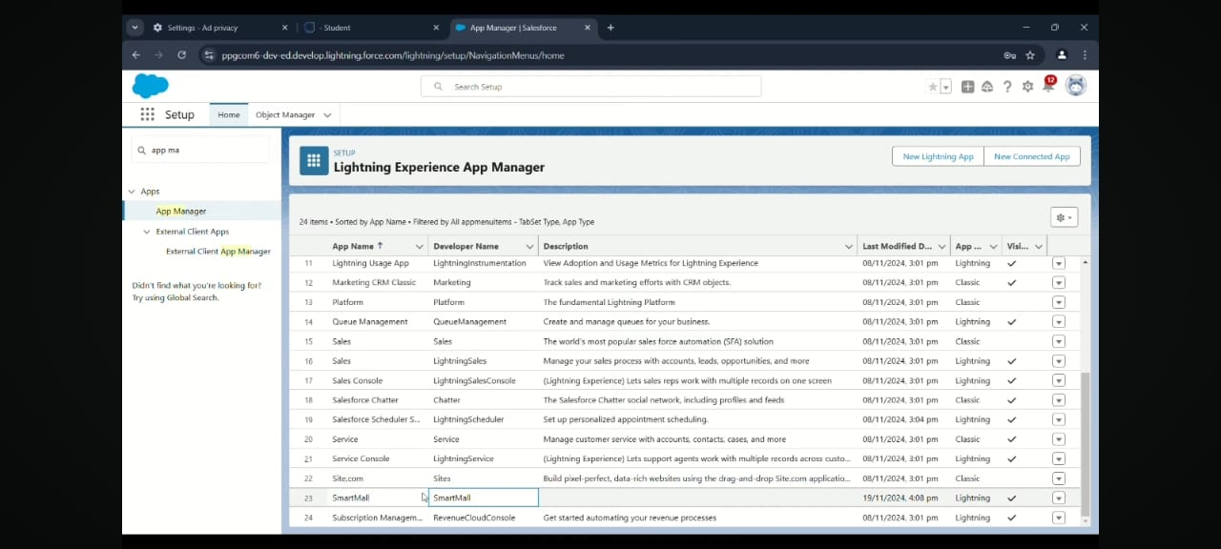

Figure 1: Creating a smart mall

**WHY ARE WE USING SALESFORCE PLATFORM FOR THIS PROJECT**

We're using Salesforce for the Mall Management App because it lets us build the app quickly without a lot of complicated coding. It's flexible, so we can easily customize it to fit the specific needs of managing a mall. Salesforce keeps everything organized in one place, making it easy to handle tenant info, leases, and maintenance issues. It's also secure, ensuring that sensitive data is protected. With automation features, tasks can be done automatically, saving time. The user-friendly interface makes it easy for everyone to use, and the analytics tools help us make smart decisions based on data. Plus, Salesforce has a helpful community for support and additional resources, making it a great overall choice for our project.

**CREATE CUSTOM OBJECTS**

To store the data as per business requirement.

1. Create Tenant Object

2. Create Lease Tracking Object

3. Create Tenant Issues Object

**TABS**

What is tab and Types of tabs :

What is Tab:  A tab is like a user interface that is used to build records for objects and to view the records in the objects.

**CREATE FIELDS AND RELATIONSHIPS**

Now it’s time for you to think out of the box for your organization. You have successfully created the database objects for the organization but now all eyes turn on you as you have to define what sort of information the objects store which you have created. As a life saver of your organization you come up with the idea of creating fields to store different types of data.

Types

1.lookup

2.master detail

3.many to many

4.self

5.external

6.hierarchial

7.standard object

**CREATE THE LIGHTNING APP**

An app is a collection of items that work together to serve a particular function. In Lightning Experience, Lightning apps gives users access to sets of objects, tabs, and other items all in one convenient bundle in the navigation bar. Lightning apps let you brand your apps with a custom color and logo. You can even include a utility bar and Lightning page tabs in your Lightning app. Members of your org can work more efficiently by easily switching between apps.

There are two types of Salesforce Applications:

* Standard Apps
* Custom Apps

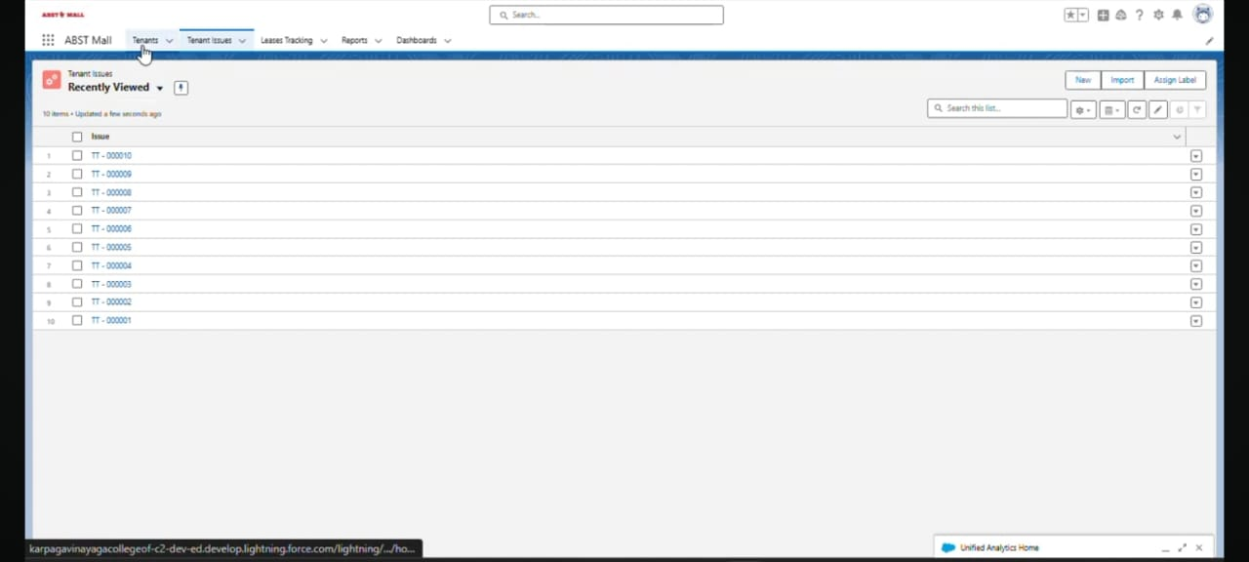

Figure 2: User Data Entry

**STANDARD APPS**

Standard apps come with every occurrence of Salesforce as default. Community, Call Center, Content, Sales, Marketing, Salesforce Chatter, Site.com, and App Launcher are included in these apps. The description, logo, and label of a standard app cannot be altered.

**CUSTOM APPS**

Custom apps are created according to the needs of a company. They can be made by putting custom and standard tabs together. Logos for custom apps can be changed.

**RECORD INSERTION**

Creating records in Salesforce is a fundamental and essential activity that serves multiple purposes, contributing to the effective management of data, streamlined processes, and overall success of an organization.

**CREATE FLOWS**

In Salesforce, a Flow is a powerful tool that allows users to automate complex business processes by orchestrating and automating sequences of tasks, data manipulations, and user interactions. Flows are designed through a visual interface, making them accessible to users with varying technical expertise.

**APEX TRIGGERS**

A trigger is a set of Apex code that runs before or after DML(Data Manipulation Language) events.

A DML event could be a variety of data processing tasks that include the standard insert, update, and delete commands.

With Apex triggers, you can automate tasks that would otherwise be nearly impossible to accomplish using only the Salesforce user interface. Triggers enable you to create custom scripts that you can implement according to your needs, and the only limitation is your coding skills.

There are two Salesforce Apex trigger types:

**BEFORE TRIGGERS**. These are helpful in cases that require a validation process before accepting a change. They run before any database changes.

**AFTER TRIGGERS**. These are helpful in cases where you need to modify your database records and when the necessary value is stored in other records. They run after any database changes. Both types will help you perform custom tasks and manage records effectively. They can help you perform bulk actions as they can handle several records simultaneously.

How to create a new trigger :

1. While still in the trailhead account, navigate to the gear icon in the top right corner.
2. Click on developer console and you will be navigated to a new console window.
3. Click on the File menu in the toolbar, and click on new Tigger.

Enter the trigger name and the object to be triggered.

1.Insert

2.Update

3.Delete

4.Merge

5.Upsert

6.Undelete

**TRIGGER SYNTAX**

Trigger triggername on objectname(triggerevents){

Code blank

}

**APEX**

It is a language developed by salesforce.com

**ASYNCHRONOUS APEX**

Asynchronous Apex in Salesforce refers to a programming paradigm where code execution is detached from the immediate context and occurs independently, typically in the background. This approach is designed to handle long-running processes, heavy computations, or tasks that should not block user interactions.

**CREATE REPORTS AND DASHBOARDS**

Salesforce Reports and Dashboards are powerful tools that empower users to visualize and analyze data within the Salesforce platform. They play a crucial role in providing insights, monitoring performance, and making informed business decisions. The solution design for the CRM application to manage the mall involves several detailed steps. First, we develop comprehensive data models to represent customer information, tenant details, sales data, and inventory levels. These models ensure that all relevant data is accurately captured and stored. Next, we design user interfaces that are intuitive and user-friendly, allowing mall management and customers to easily navigate the application. This includes dashboards for real-time sales tracking, tenant management screens, and customer support interfaces. Business logic is then implemented to automate processes such as marketing campaigns, loyalty programs, and event management. This logic ensures that the application operates efficiently and meets the business objectives. Throughout the design process, we document each element thoroughly, including data models, user interface designs, and business logic. Relevant screenshots are included to provide visual references and ensure clarity. This detailed documentation serves as a blueprint for the development and implementation phases, ensuring that the CRM application is built to meet the specific needs of mall management and enhance overall operational efficiency.

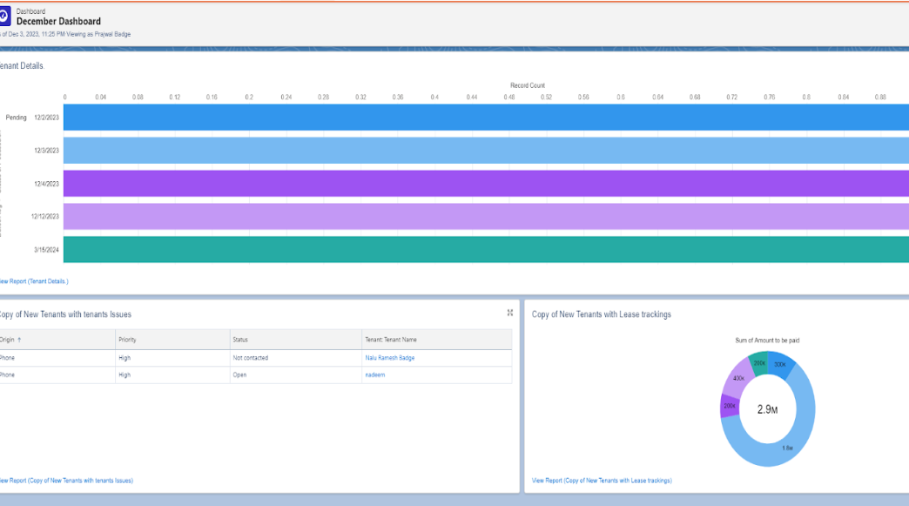

**TESTING AND VALIDATION**

**1. UNIT TESTING FOR APEX CLASSES:**

- Write test methods to validate the functionality of each Apex class.

- Ensure that all methods and logic within the classes are tested for expected outcomes.

- Use assertions to verify that the results match the expected values.

**2. UNIT TESTING FOR TRIGGERS:**

- Create test cases for each trigger to ensure they execute correctly under various conditions.

- Test both positive and negative scenarios to cover all possible outcomes.

- Validate that triggers perform the intended actions without causing errors or unexpected behavior.

**3. CODE COVERAGE:**

- Aim for high code coverage by writing comprehensive test cases.

- Ensure that at least 75% of the code is covered by tests, as required by Salesforce.

- Identify and address any uncovered areas to improve overall test coverage.

**4. MOCKING AND STUBBING:**

- Use mocking and stubbing techniques to simulate external dependencies and services.

- Ensure that tests are isolated and do not rely on external systems or data.

- Validate the behavior of the code in a controlled environment.

**5. USER INTERFACE TESTING:**

- Conduct manual testing of the user interface to ensure it is intuitive and user-friendly.

- Test all UI components, including forms, buttons, and navigation elements, for functionality and responsiveness.

- Validate that the UI meets design specifications and provides a seamless user experience**.**

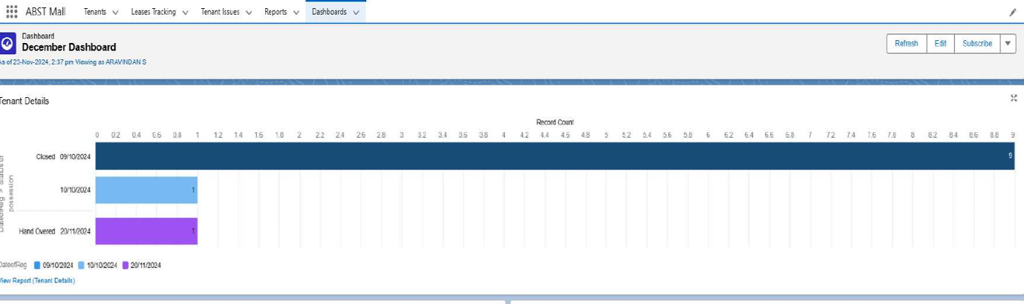

**Figure 3: Dashboard**

**6. AUTOMATED UI TESTING:**

- Implement automated UI tests using tools like Selenium or Provar.

- Create test scripts to validate the functionality of the UI across different browsers and devices.

- Ensure that automated tests cover critical user flows and scenarios.

**7. INTEGRATION TESTING:**

- Test the integration of different components and modules to ensure they work together seamlessly.

- Validate data flow and interactions between the CRM application and external systems.

- Identify and resolve any integration issues that may arise.

**8. PERFORMANCE TESTING:**

**-** Conduct performance testing to evaluate the application's responsiveness and stability under load.

- Use tools like JMeter or LoadRunner to simulate user traffic and measure performance metrics.

- Identify and address any performance bottlenecks to ensure optimal performance.

**9. USER ACCEPTANCE TESTING (UAT):**

- Involve end-users in testing the application to validate that it meets their requirements and expectations.

- Conduct UAT sessions to gather feedback and identify any usability issues.

- Make necessary adjustments based on user feedback to improve the overall user experience.

**10. REGRESSION TESTING:**

- Perform regression testing to ensure that new changes or updates do not introduce new issues.

- Re-run existing test cases to validate that previously working functionality remains intact.

- Continuously update and maintain the test suite to cover new features and changes.

**KEY SCENARIOS ADDRESSED BY SALESFORCE IN THE IMPLEMENTATION PROJECT**

1. **INTEGRATION WITH EXTERNAL SYSTEMS:** Seamless integration with existing systems and platforms for a unified management experience.

2. **PERFORMANCE MONITORING:** Continuous monitoring of system performance to ensure optimal operation.

3. **USER TRAINING AND SUPPORT:** Providing training and support to users for effective utilization of the CRM application.

4. **CUSTOMIZATION:** Customizable features to meet the specific needs of the mall management.

5. **COMPLIANCE:** Ensuring compliance with relevant regulations and standards.

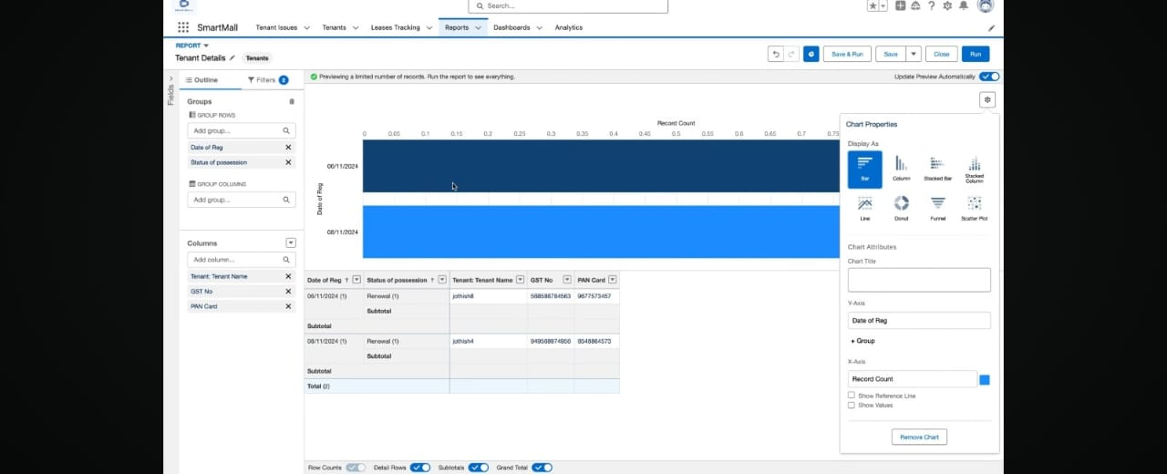

Figure 4: output

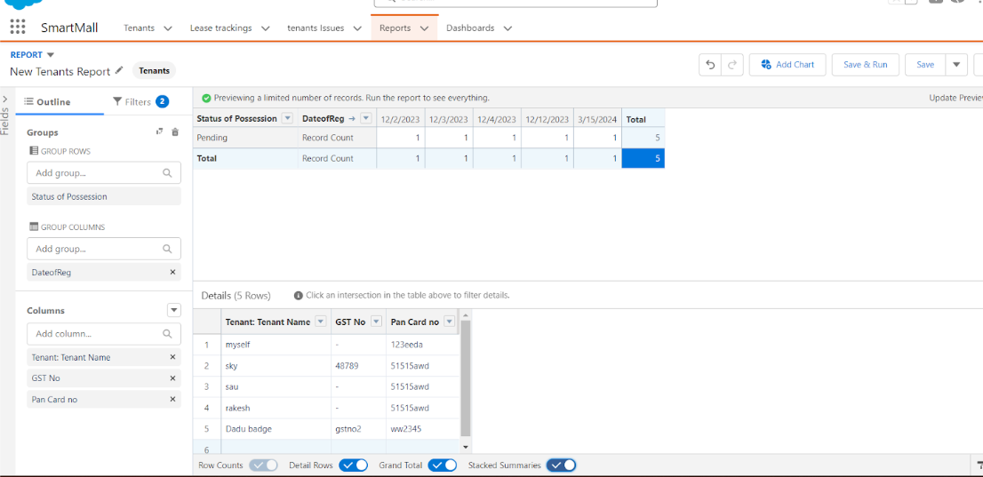



Figure 3: Date of Registration

**CONCLUSION**

In conclusion, the CRM application for managing the mall is designed to revolutionize mall operations by integrating advanced features and functionalities. By centralizing customer data, automating marketing campaigns, and providing real-time sales tracking, the application enhances customer engagement and boosts sales. The tenant management system ensures efficient handling of lease agreements and rental payments, while the integrated customer support system addresses inquiries and feedback promptly. The application also includes tools for event management, loyalty programs, and inventory management, ensuring a seamless experience for both mall management and customers. Robust security measures and compliance with regulations ensure data privacy and protection. The user-friendly interface and mobile app integration provide easy access to information and services on the go. Detailed analytics and reporting tools offer valuable insights into customer behavior and sales trends, enabling data-driven decision-making. The scalable architecture accommodates future growth and additional features, making the CRM application a comprehensive solution for mall management. Overall, this project aims to optimize operations, enhance customer experience, and drive business growth, positioning the mall for long-term success.

**REFERENCES**

1.[sedhuraman45/A-CRM-APPLICATION-TO-MANAGE-THE-MALL](https://github.com/sedhuraman45/A-CRM-APPLICATION-TO-MANAGE-THE-MALL).

2. [Mall Management – ICM](https://icm.in/mall-management/).

3. [paranjothi7/Team-3-CRM-for-Mall: a CRM application to manage the mall](https://github.com/paranjothi7/Team-3-CRM-for-Mall/).

4. [Subhasree06/A-CRM-Application-to-Manage-the-Mall](https://github.com/Subhasree06/A-CRM-Application-to-Manage-the-Mall).

5. [Guided Projects](https://nme.smartinternz.com/saas-guided-project/1/a-crm-application-to-manage-the-mall).

6. <https://youtu.be/l0TYh6GlfK4?si=lyUpbPmyON1tVt3P>.

7. <https://youtu.be/r6Rgaz-DokI?si=VdJ-zZ3tv79bPf3S>.